Microservices:

If package everything in one ear: long release cycle, big budget, big delays, many unused features, expensive to change, difficult to scale, slow payback of return on investment, drag on business model innovation, source of conflict b/w IT and business, difficult to understand monolithic codebase

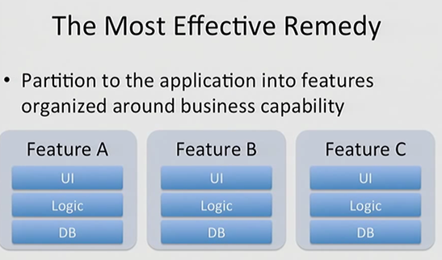

Break big app into small microservices, each with own backend and business logic. Could be just backend data-services. No need of UI. Deliver each service as separate microservice executable.

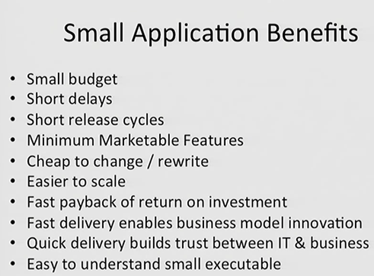

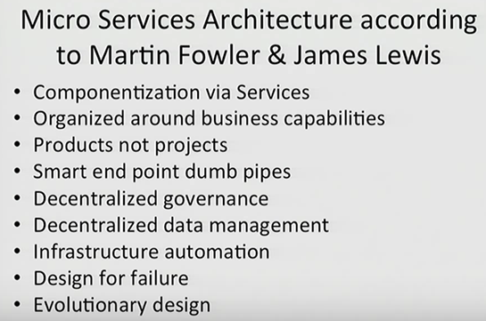

Business functionality sliced into layers for eg: ebay : diff service for handling customer profiles, other for auction, another for payment.

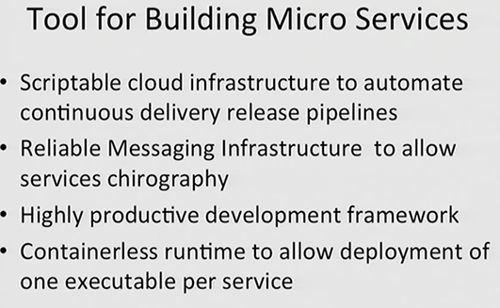

Light-weight development framework.

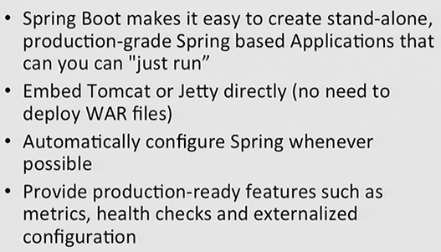

**Spring-boot-starter-actuator:**

Some pre-defined endpoints like localhost:8080/beans: spring beans which are registered.

/metrics: memory the app has, how many times endpoints were executed

/dump:

**Spring-boot-starter-remote-shell:**

Using default password for shell access: 252b1332-cbdb-45dd-8427-fd644a4500b3

Username: user

**Flywaydb dependency**

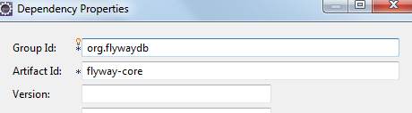

Automatically create tables for us. Looks for a .sql file under db/migration/ and each file executes as 1 transaction.

**Command Line Runner**

Things we wish to do as soon as spring boot application loads up, we can do using the command line runner like initializing the data. CommandLineRunner is a simple interface with the run method taking in String[] arguments.

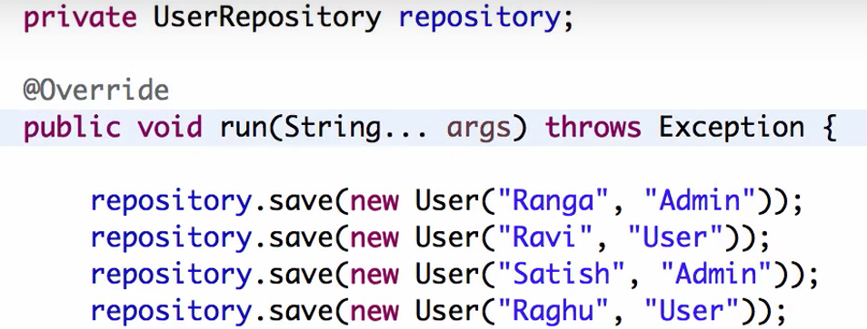

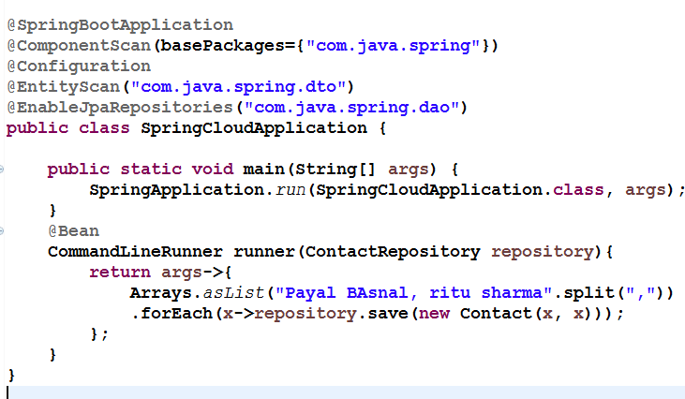

**Distributed tracing and Zipkin:**

**Monolithic applications:**

They have scaling problems. 1 single application doing everything. Large app. Difficult to understand, manage, maintain, test, deploy. Difficult to adapt to new technology.

**Microservices**

1. Small: Do 1 thing well. 1 responsibility,
2. 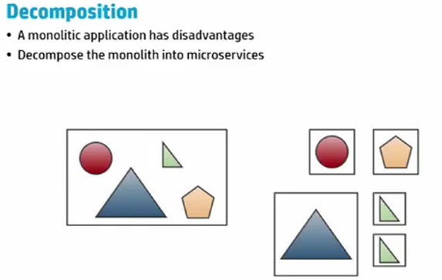

Once decomposed, one block can be deployed multiple times into production, is reusable.

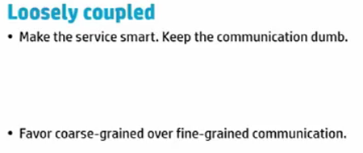

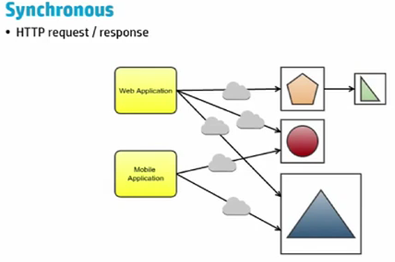

Synchronous: Not good idea for large application with diff services. Gateway can be used to make it faster.

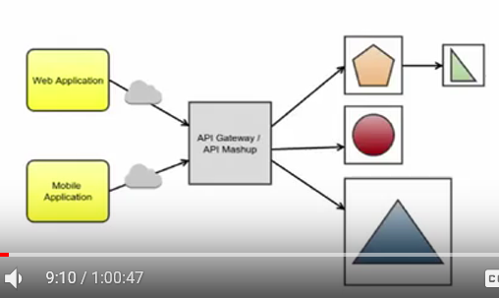

Or api meshup like a composite service which can call other services internally. Orchestrating services.

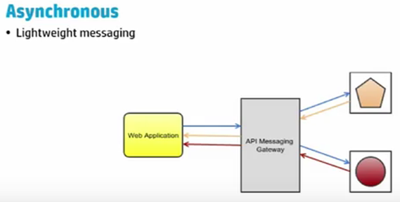

Single point of failure if service fails in synchronous app.

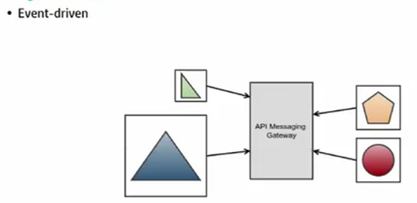

Microservices starts talking to each other. Publish subscribe.

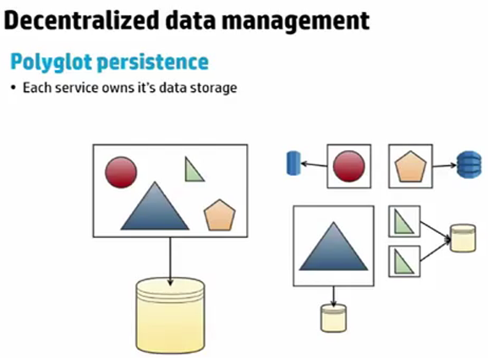

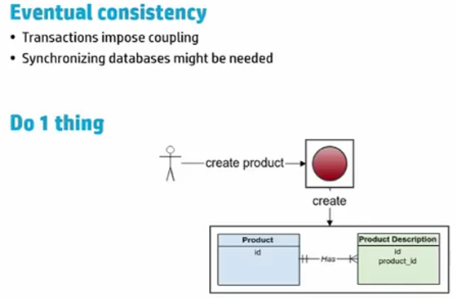

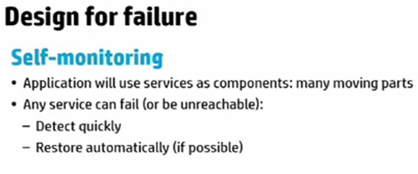

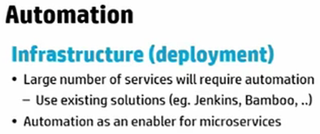

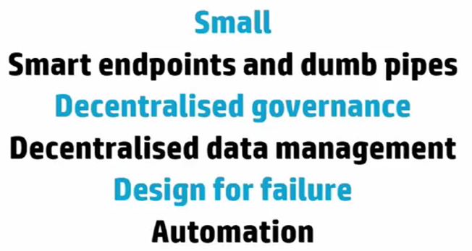

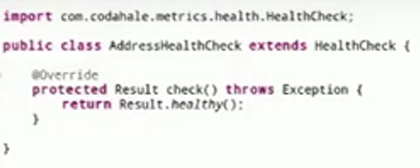

Default drop wizard comes with a jetty application, not with tomcat

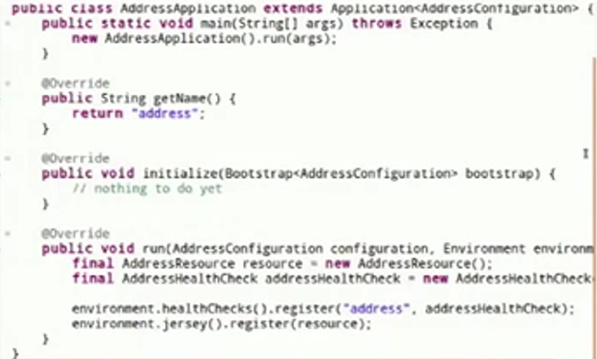

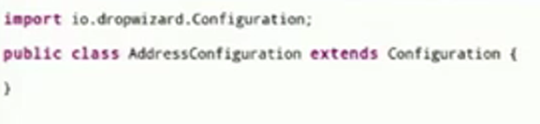

Drop wizards need configuration to connect to other web-service/ db

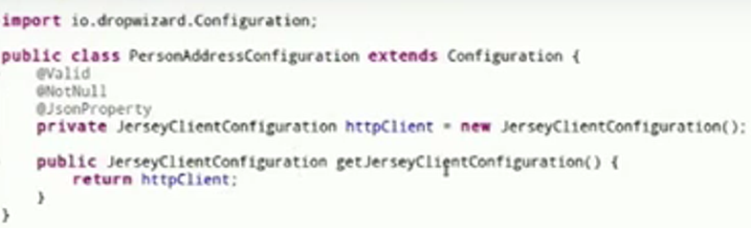

Here it uses jersey client to call other web services.

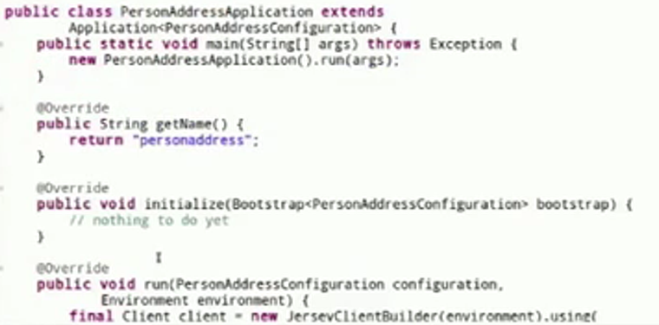

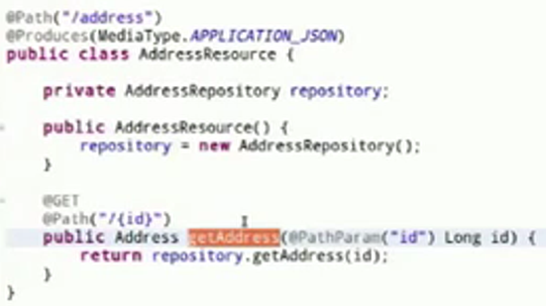

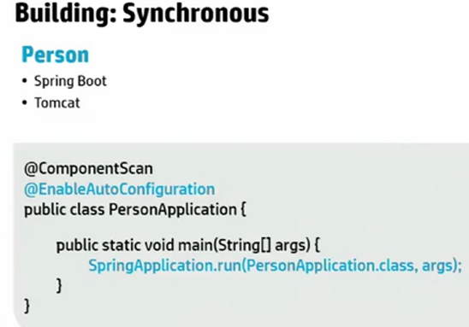

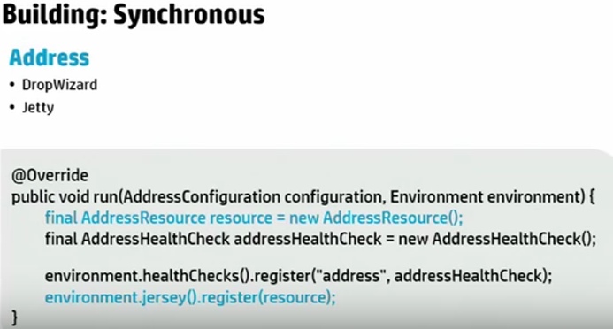

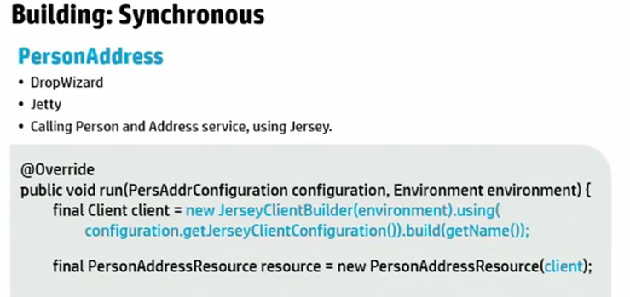

Jersey client calling 2 other microservices.

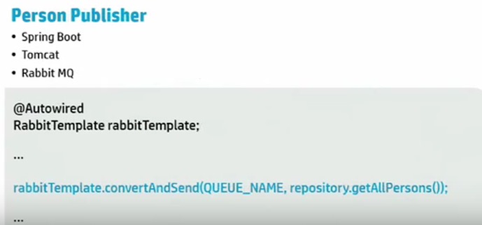

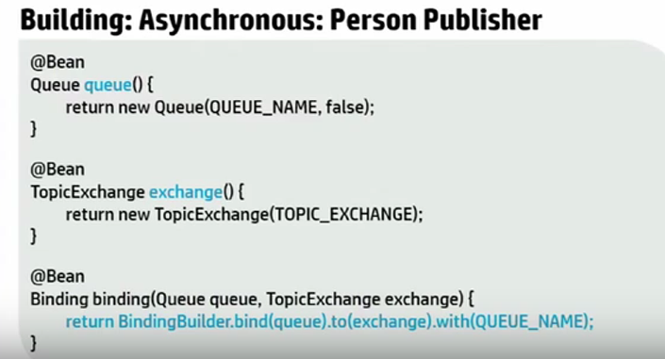

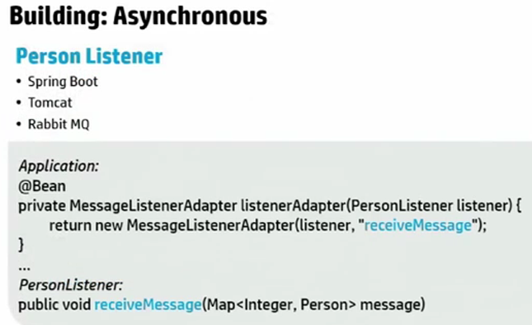

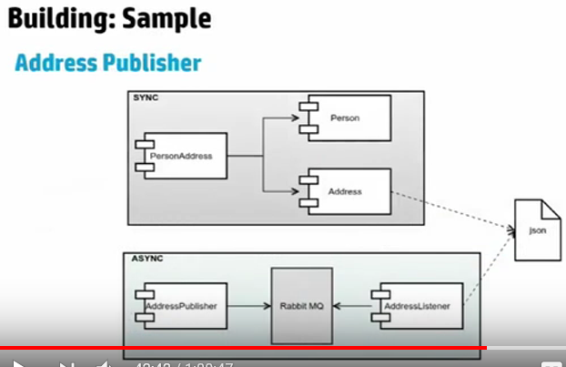

Who invoked the service, tracked using correlationid

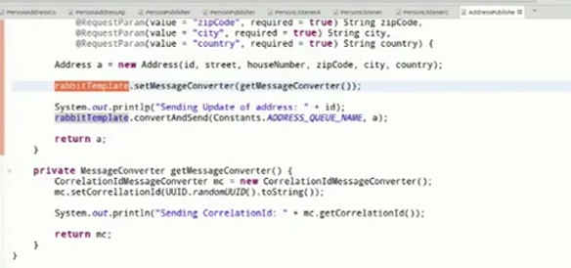

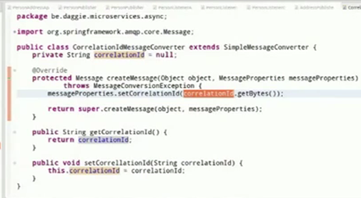

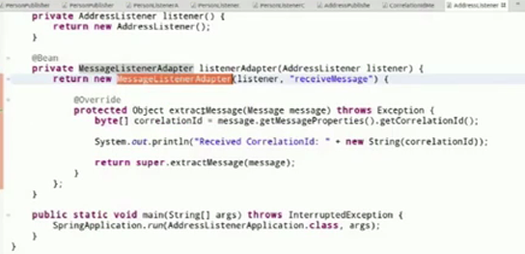

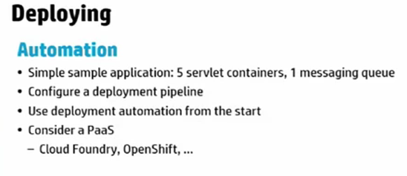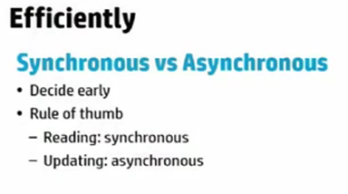

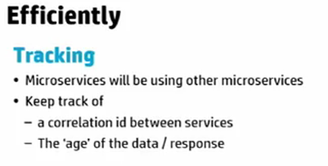

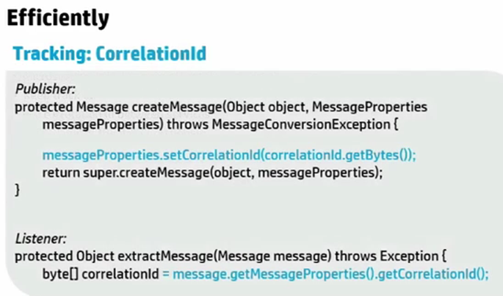

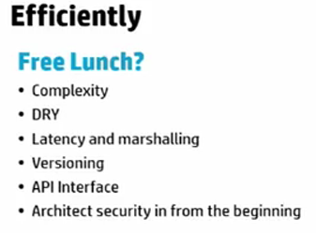

Discovery service: Eureka: Registry service: where they are located

Spring cloud: java –jar : can be executed from anywhere, whether local machine/ cloud foundry/ aws

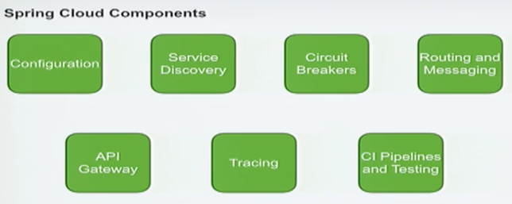

Circuit breakers: Prevent failures

Tracing: visualize/ trace request.

CI pipelines:

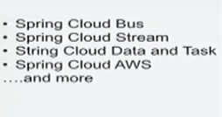

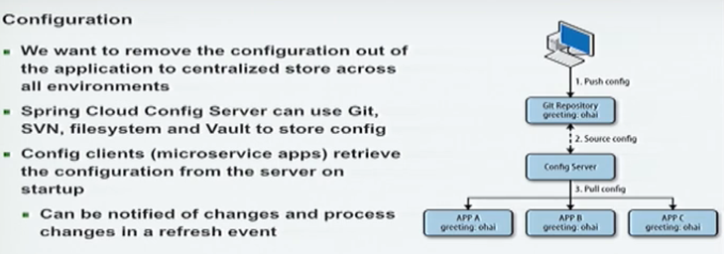

To change the logging level, do not have to go to all the applications to do that.

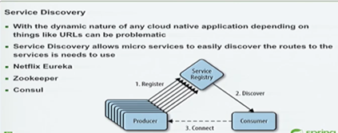

Instances may change. Where instances are

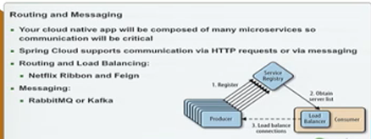

Route specific messages to particular service. Built in Client side Load balancer which will route the request accordingly for us.

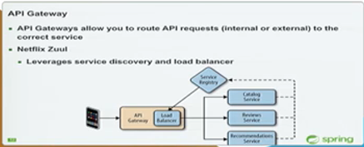

Can shield client requests from services behind the gateway. Services can be scaled.

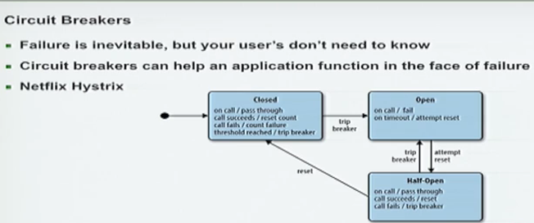

If one service having problem, request is prevented from hitting that service and served with cached data. Helps preventing cascading failures.

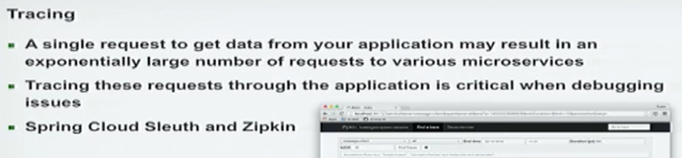

ElasticSearch also for logging data

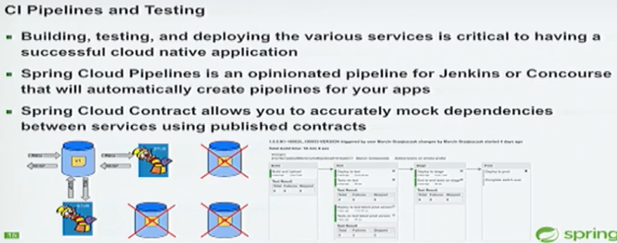



Spring cloud will startup configserver, eureka server and zipkin

Configserver.yml: specify where is config file

Application.yml: will apply these settings to all servers

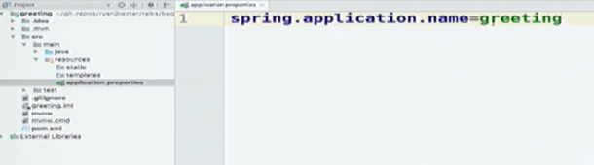

Configserver uses it to find the name of the config file for that service. It matches greeting.yml filename. Also this is the name with which my application registers itself in Eureka. I am greeting service, located at this url.

@EnableDiscoveryClient: Registers the app with Eureka.

We need to provide sampler to spring cloud suit to send log information off the zipkin

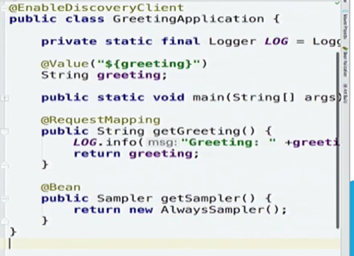

AlwaysSampler sends everything to zipkin

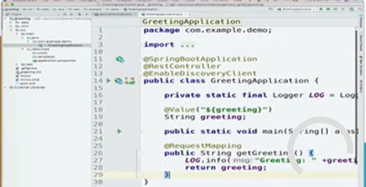

Service dependencies:

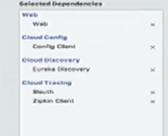

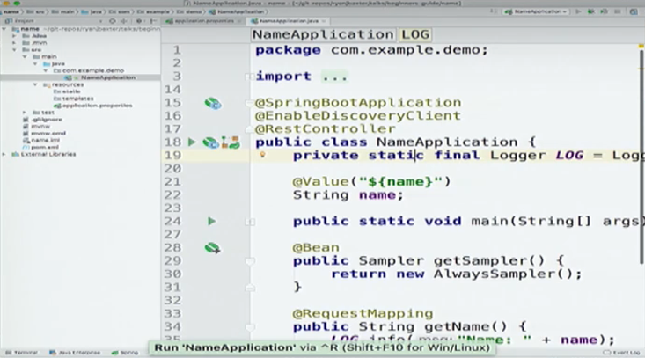

ConfigServer.yml: config server configurations

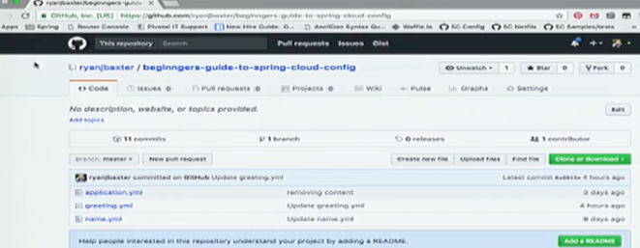

Repository

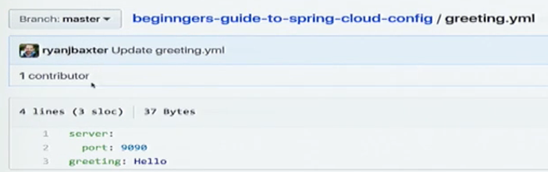

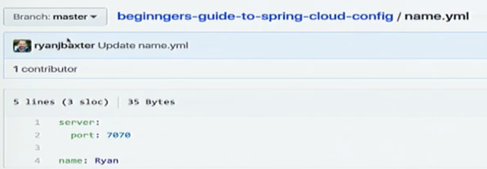

**Service which combines these 2 services**

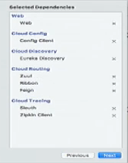

Added ribbon, zuul, feign

To make request to the greeting service, using RestTemplate:

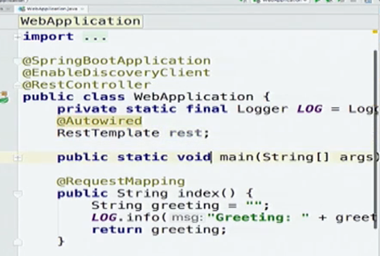

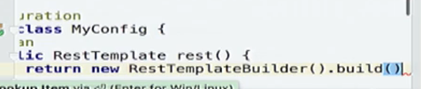

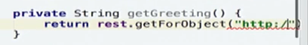

url where greeting service is located

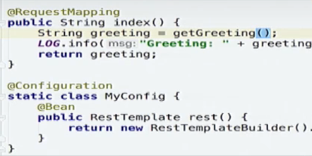

Now instead of hardcoding url, will use service discovery to find the url

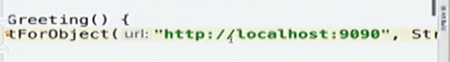

Aslo don’t know how many instances running, may have moved down from 2 to 1

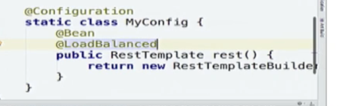

So just add @LoadBalanced annotation.

Instead of specifying url, change it to the name of the service

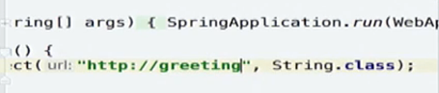

Also adding sampler:

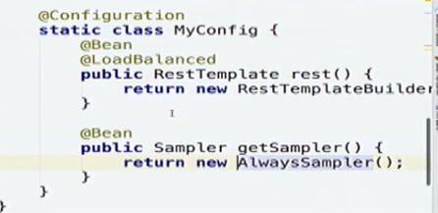

We can use LoadBalancer to get other service too, but using Feign now. With Feign, can use webmvc mapping annotations to do that.

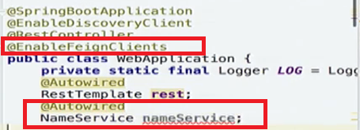

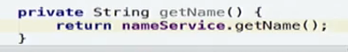

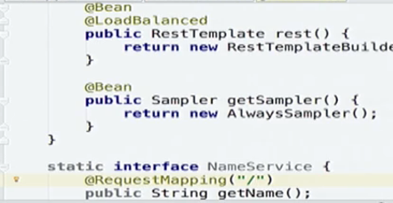

Annotate this interface with @FeignClient with the name of the service you want to inject

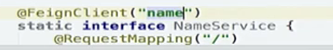

EnableFeognClients in application. Also Enable Zuul on this along with Feign

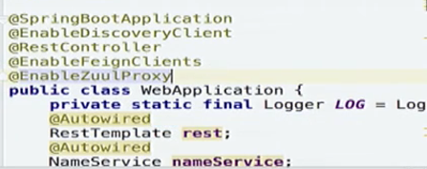

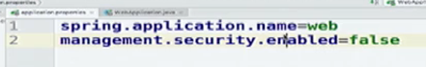

Zuul proxy added some routes to teh application

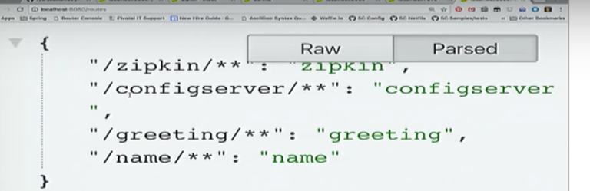

So can call those services also from this application.

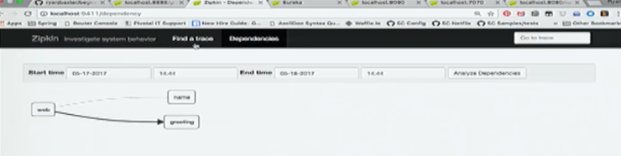

Tracing tool: zipkin

/dependency

/metrics:

/health

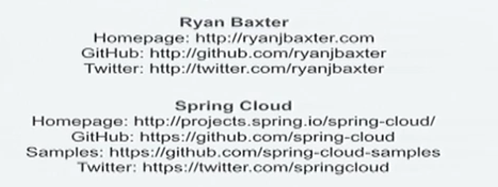

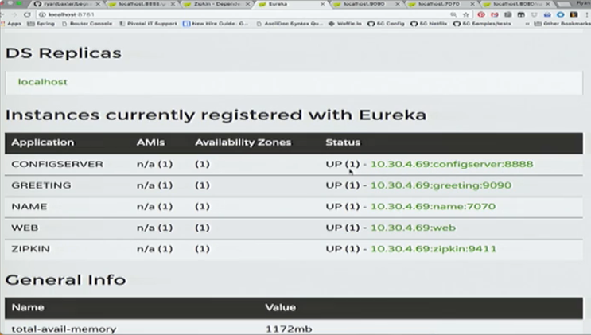

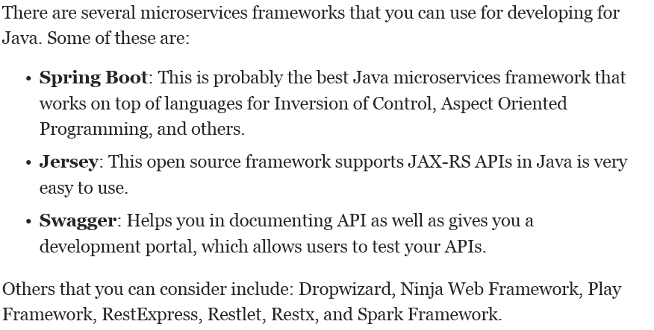

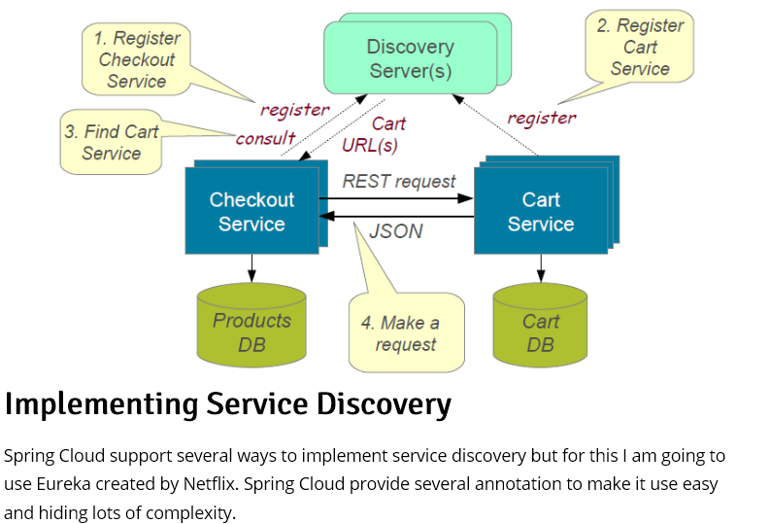

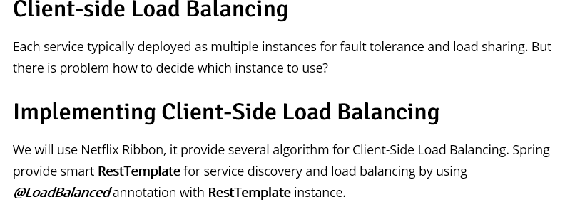

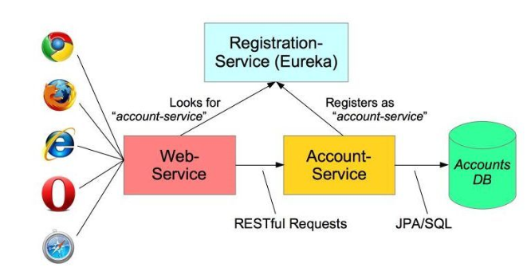

we are using Netflix Ribbon as a client-side load balancer. That enables us to achieve fault tolerance and increase the reliability and availability through redundancy. We are using Netflix Foreign for writing declarative REST client, and integrating Ribbon and Eureka to provide a load balance HTTP client.

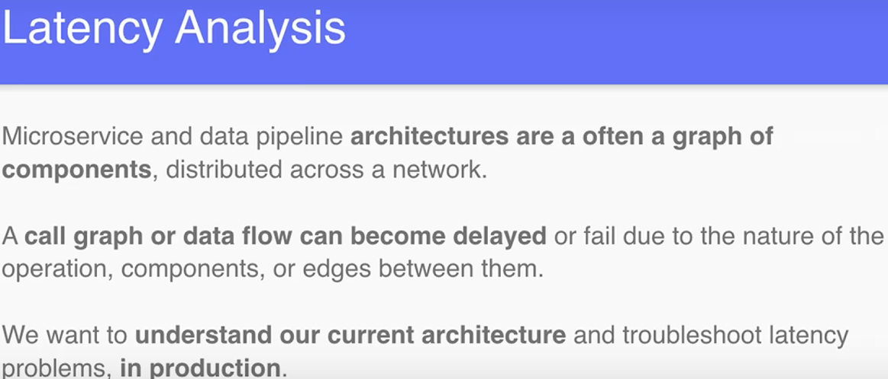

if you apply the Microservice Architecture pattern you must then apply numerous successor patterns including service discovery patterns and the Circuit Breaker pattern. first decision you must make is whether to use a [Monolithic architecture pattern](http://microservices.io/patterns/monolithic.html) or the [Microservice architecture pattern](http://microservices.io/patterns/microservices.html). If you pick the Microservice architecture pattern you must choose numerous other patterns to deal with the consequences of your decision.

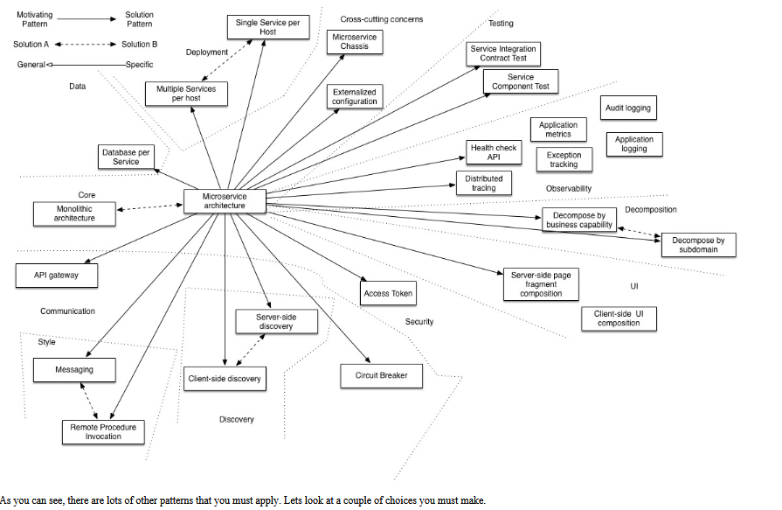

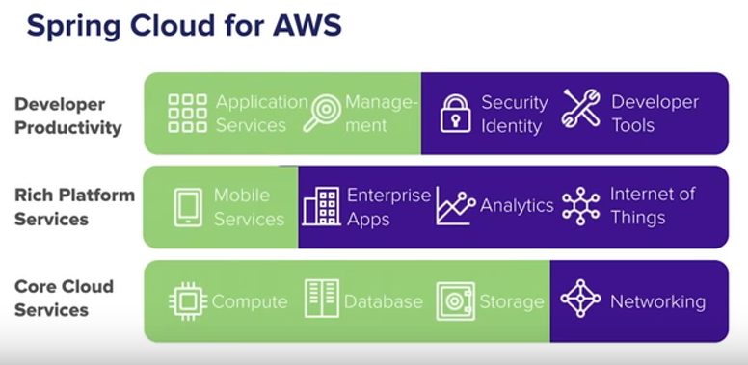

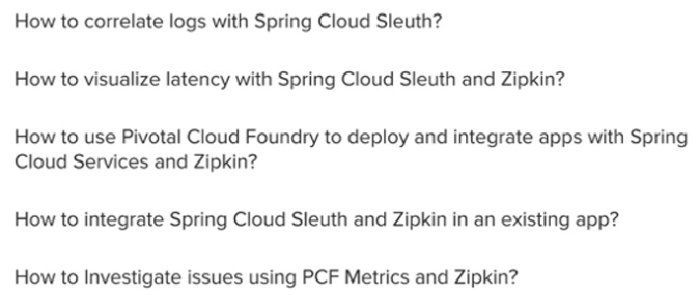

1. Which server instance was exception thrown, if many services running on many instances.
2. So through span (time for each service), trace(set of spans), logs() , tags(key value pair) try to find out the same
3. 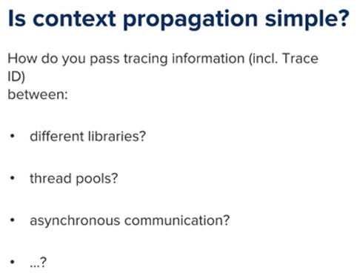
4. 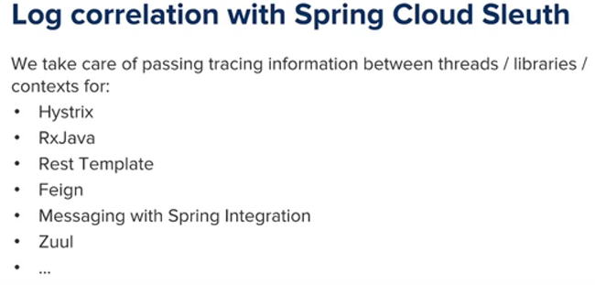
5. 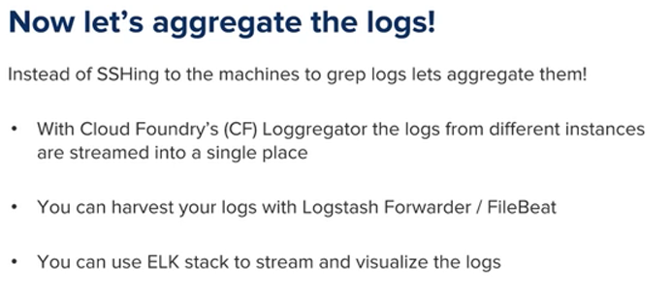
6. 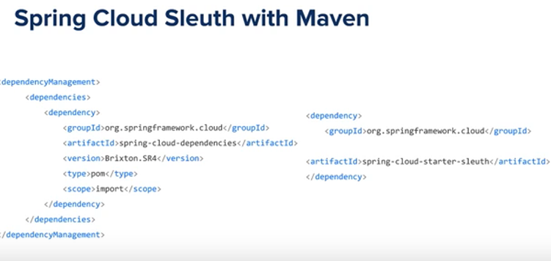

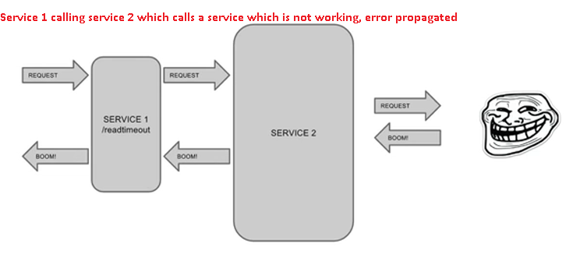

**ELK Stack (Elasticsearch logstash kibana)**

**Log analysis:**

